1.Write a shell scripting to compare two strings whether they are equal or not

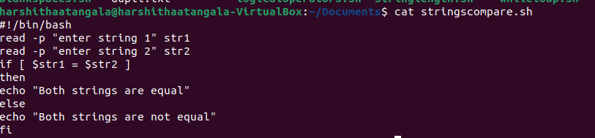

2.Execute a simple for loop

